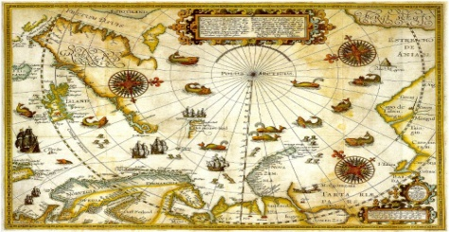
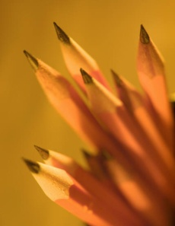
SEmester 1—7th grade Social Studies Plan/Syllabus

Topics/Activities of Semester 1
Social Studies Learning Targets
Oregon State SS Content Topics-7th grade
~Ancient civilizations studied:
Mesopotamia, India, China, Greece and Rome and Major world religions
~SS 101/major historical eras and time lines
~World geography, vocabulary and connections between people in history
~ Evaluate and make: maps, charts and graphs
~Cornell note-taking, and study skills
~communication/discussion skills in SS
CCSS in READING
Students will read closely and find answers explicitly in a text (right there answers) and answers that require an inference. (RI 7.1)
Students will be able to compose an objective summary stating the key points of the text. (RI.7.2)
CCSS in WRITING
Students will be able to write arguments to support claims in an analysis of topics or texts, using valid reasoning and relevant and sufficient evidence. (W.7.1)
Students will be able to write informative short essays to explain complex ideas and information clearly. (W.7.2)
CCSS in SPEAKING/LISTENING
Students will be able to engage effectively in a range of collaborative discussions (one-on-one, in groups, and teacher led) with diverse partners, on grade level topics, texts and issues. (SL.7.1)

Dear Parents and/or Guardians,
Hello and welcome to Social Studies! I am excited to be an important part of your student’s 7th grade experience at SMS. Our focus this year will be history of the Eastern Hemisphere, world geography and critical thinking skills. Proficiency in learning will be shown through content based assessments, reading comprehension assignments/assessments and short writing assignments/assessments.
It is crucial that students have good attendance, follow classroom expectations and be engaged in all learning activities. Students need to bring supplies and their student planner on a daily basis. The use of the planner is required and not optional. The planner is an important communication tool between school and home plus it’s your student’s hall pass and record of assignments, tests and HW.
I look forward to working with your student and having a part in a great school year. Please contact me if you have any questions or concerns.
Therese Tardif
SMS-7th Grade Social Studies
ttardif@scappoose.k12.or.us
or 503-543-7163 (SMS main office)
1. Culture: What makes each civilization or society unique? (Religious beliefs, behaviors, entertainment, etc.)
2. Time, Continuity and Change: What is the history of past peoples in the Eastern Hemisphere and how am I connected to those from the past? Why study history? Can we learn from history?
3. People, Places, and Environments: Why people and places are located where they are and what patterns have developed? How does geography determine the history of different civilizations?
4. Power, Authority, and Government: How and why were/are governments created, structured, maintained and changed?
5. Production, Distribution, and Consumption: How have societies (in history) satisfied their basic needs and how has profit been introduced?
6. Science, Technology, and Society: How have people in history used advancements and applied knowledge to improve society?
7. Civic Ideals and Practices: What role did citizens in history have, and what role do current citizens have within local and world communities?

See Reverse side for the Following

* | ESSENTIAL Questions/Themes of Social Studies
* | Grading with Proficiency Education

Essential Themes and Questions in Social Studies:

Grading with Proficiency Education

Critical Thinking (CT)
Assessments
Social Studies (SS) Assessments
Practice/Project Scoring

SS assessments (tests) will be valued at or near 40 points. They will include SS content and a CCSS in writing and/or reading. Being proficient in SS means students need to score at least 75% in SS content. To score at the mastery level: higher order thinking proof will be needed in writing and/or reading comprehension. Re-takes may occur but need to be within 2 weeks and/or by the end of the unit. SS assessments (along with CT assessments) will be worth 80% of the total grade.

All practice assignments and/or projects will be worth 2 or more points and will be valued at 20% of the total grade. Students are showing that they are learning and practicing the materials to be covered in assessments (both SS and CT). All late (unexcused) homework assignments and projects will receive 50% credit.

One written and one reading CT skill will be assessed this semester. Students will have multiple opportunities to score proficient or higher. These will be embedded in each SS test and/or will be stand-alone assessments. Stand-alone assessments will be worth 12-32 points. 75%=proficiency, with mastery= above 75% with higher order thinking proof/evidence. CT assessments will be worth 80% of the total grade (along with SS assessments).

Access to Synergy (grades and class information) is very important. Assignments and resources are available for viewing and downloading. See office for details and options.
Scores from practice and assessments (both SS and critical thinking) will meet the traditional A-F grading system.

